主题： 手机用途

题型：表格

The table shows the percentages of mobile phone owners using various mobile phone features.

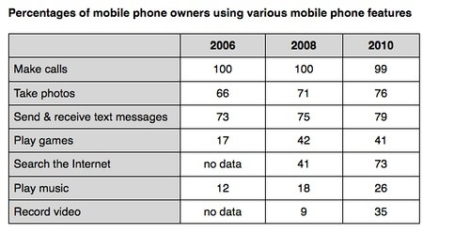

满分范文：

The table compares the percentages of people using different functions of their mobile phones between 2006 and 2010.

Throughout the period shown, the main reason why people used their mobile phones was to make calls. However, there was a marked increase in the popularity of other mobile phone features, particularly the Internet search feature.

In 2006, 100% of mobile phone owners used their phones to make calls, while the next most popular functions were text messaging (73%) and taking photos (66%). By contrast, less than 20% of owners played games or music on their phones, and there were no figures for users doing Internet searches or recording video.

Over the following 4 years, there was relatively little change in the figures for the top three mobile phone features. However, the percentage of people using their phones to access the Internet jumped to 41% in 2008 and then to 73% in 2010. There was also a significant rise in the use of mobiles to play games and to record video, with figures reaching 41% and 35% respectively in 2010.